INDUSTRIAL POWER CONTROL BY INTEGRAL CYCLE SWITCHING WITHOUT GENERATING HARMONICS

ABSTRACT

The project is designed to achieve integral cycle switching, a method to remove whole cycle, cycles or portions of cycles of an AC signal. It is a well-known and old method of controlling AC power, especially across linear loads such as heaters used in electric furnace. However the concept of achieving the cycle stealing of voltage waveform by use of microcontroller can be very precise as per the program written in assembly / C language so that the actual time-average voltage or current experienced at the load is proportionately lower than the whole signal if applied to the load. In place of a linear load to be used in the output, a series motor or lamp can be used to verify the output. One side effect of utilizing this scheme is an imbalance in the input current or voltage waveform as the cycles are switched on and off across the load.

In this project we are using comparator for zero crossing detection which is fed as an interrupt to microcontroller of PIC family. Here the microcontroller delivers the output based on the interrupt received as the reference for generating triggering pulses. Using these pulses, we drive the opto-isolators for triggering the TRIAC to achieve integral cycle control as per the input switches interfaced to the microcontroller. A lamp is provided in this project in place of a motor for demonstration purpose.

Further this project can be enhanced by using feedback mechanism to automatically maintain desired output to the load by appropriate cycle stealing.

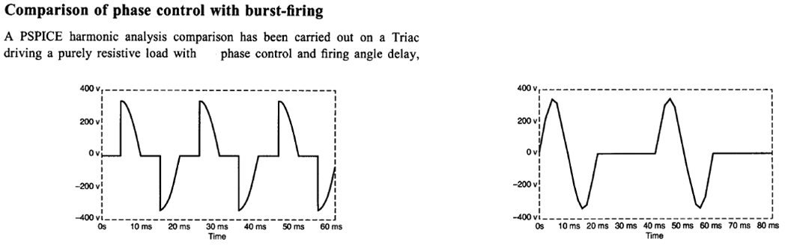

THD=61% THD=1%

BLOCK DIAGRAM

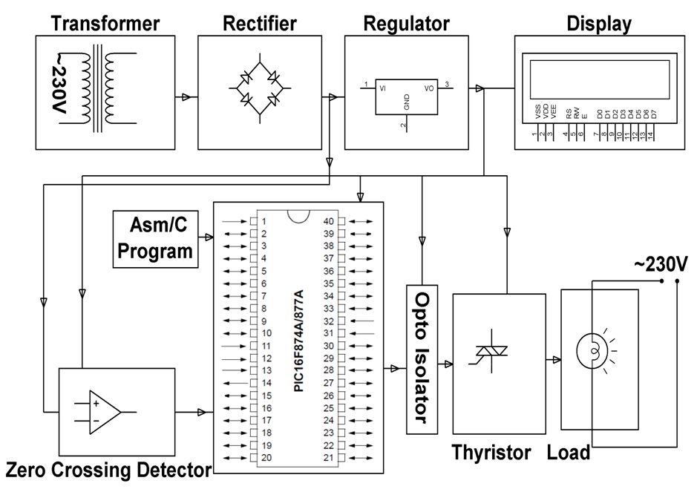

**SOFTWARE REQUIREMENTS:**

HI-TECH PICC Tool suite

Language: Embedded Cor Assembly

**HARDWARE REQUIREMENTS:**

PIC series Microcontroller, Op-amp, Opto-isolator, TRIAC, Resistors, Capacitors, Diodes, Voltage Regulator, LED, Crystal, LCD, Lamp.